4.4 Setup & Installation Guide:
1.Prerequisites:
Before running the CampusCare application, the following software must be installed:
• Node.js
• npm
• Expo Go or iOS Simulator
• VS Code
• Supabase
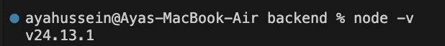
2.Backend Setup:
1. Open backend folder:
cd backend
2. Install dependencies:
npm install
3. Run backend server:
node server.js
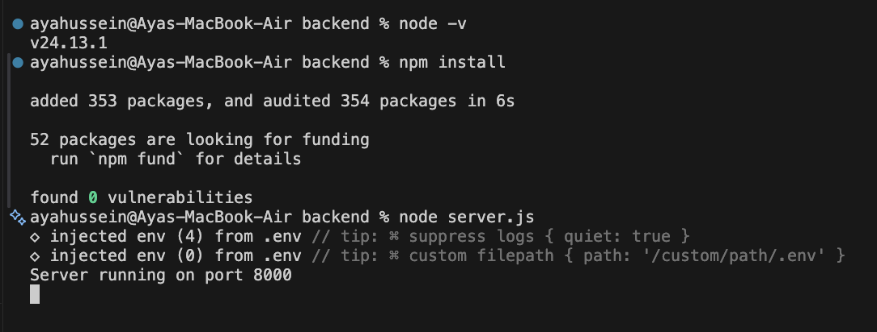

3.Environment Variables:
Create a .env file inside the backend folder.
Example:
PORT=8000
SUPABASE_URL=https://dmmrrvghkdxtticeabuj.supabase.co
SUPABASE_KEY=sb_publishable_vSH3L1DL5ZiaGh4b-puubw_GMFIew3m
JWT_SECRET=campuscare_secret
4.Frontend Setup:
1. Open frontend folder:
cd frontend
2. Install dependencies:
npm install
3. Start Expo:
npx expo start
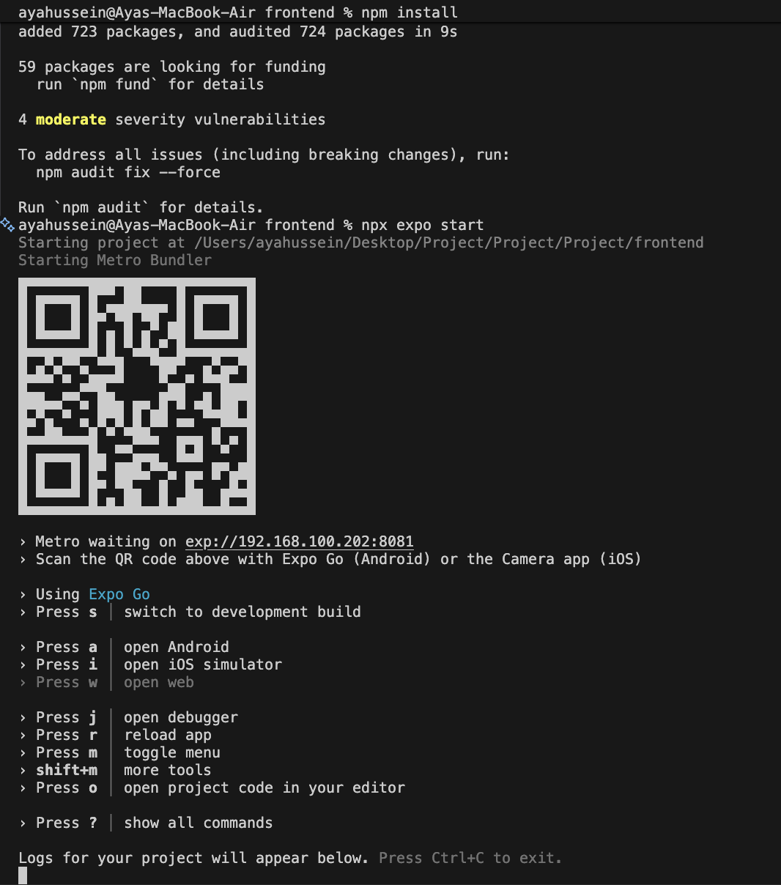
5.API Configuration:
The frontend uses the local IP address to connect to backend APIs.
Example:
http://192.168.1.25:8000
6.Database Setup:
The project uses Supabase PostgreSQL database.
Main tables:
users
• id
• name
• email
• password
• role
issues
• id
• category
• description
• location
• status
• user_id
7.API Testing:
Thunder Client was used to test backend APIs.
Tested APIs:
• Login API
• Get My Issues API
• Get Issue Details API
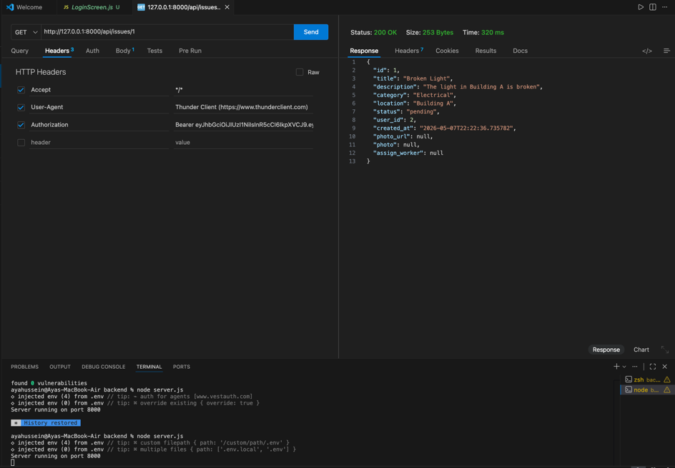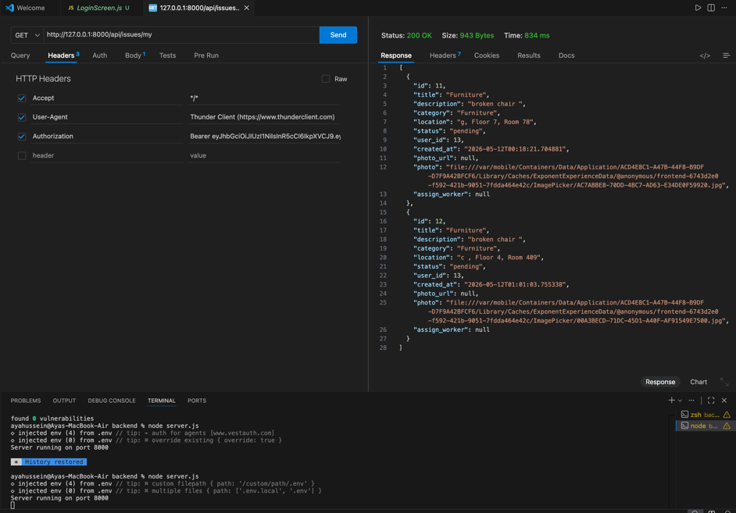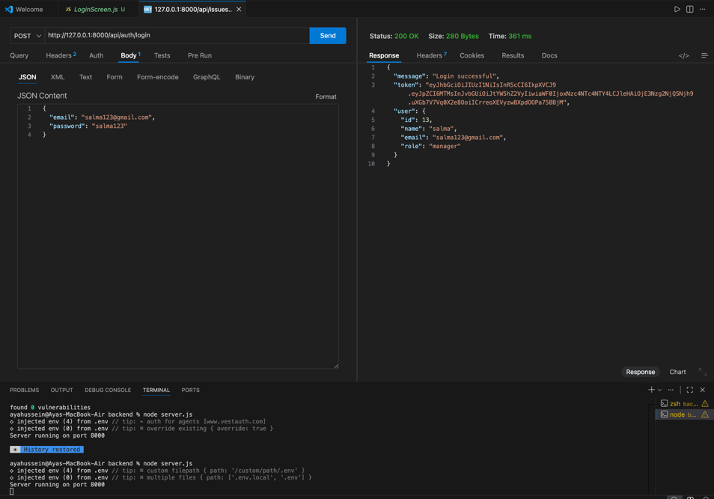
8.Frontend Testing:
Frontend screens were tested successfully.
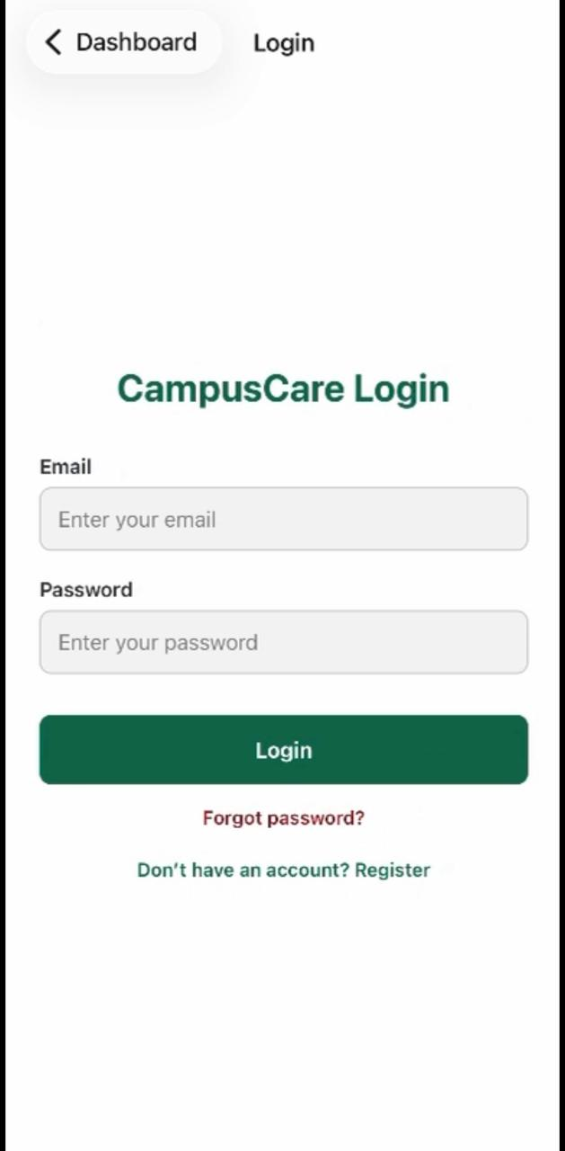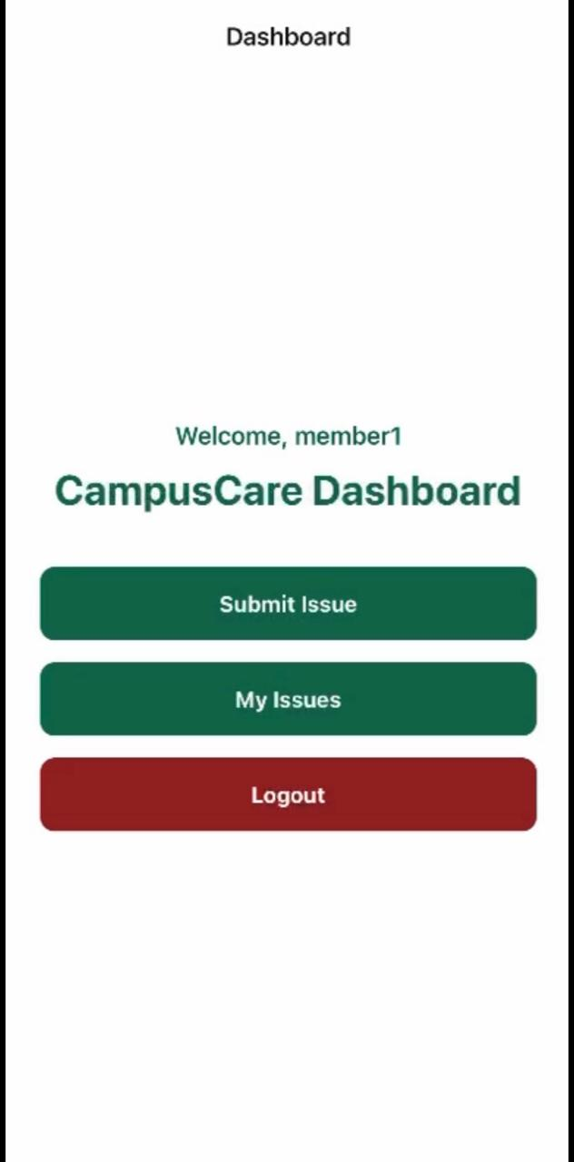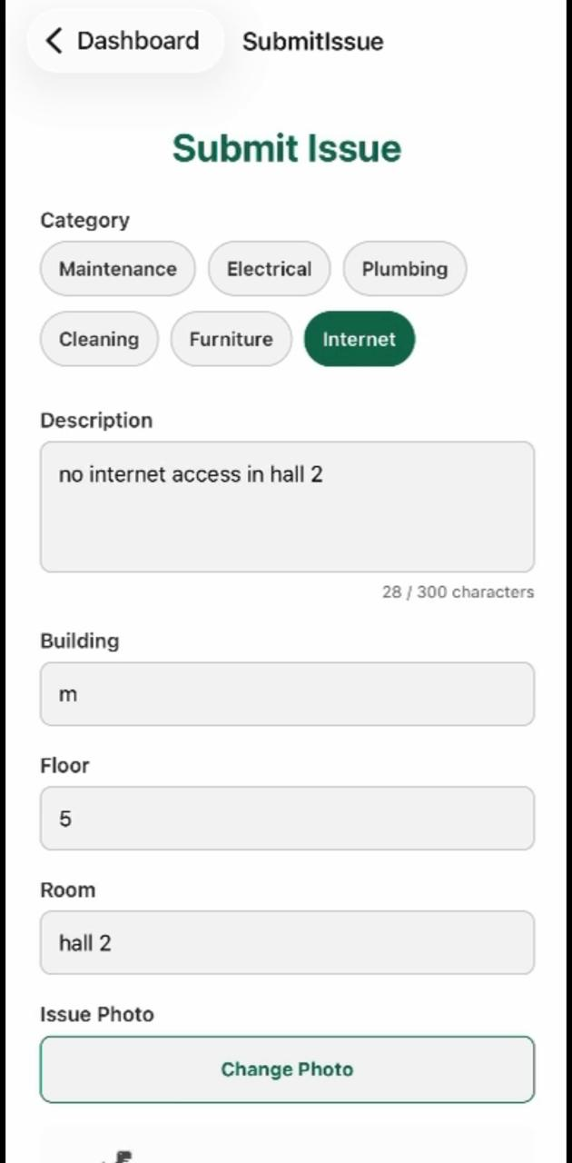
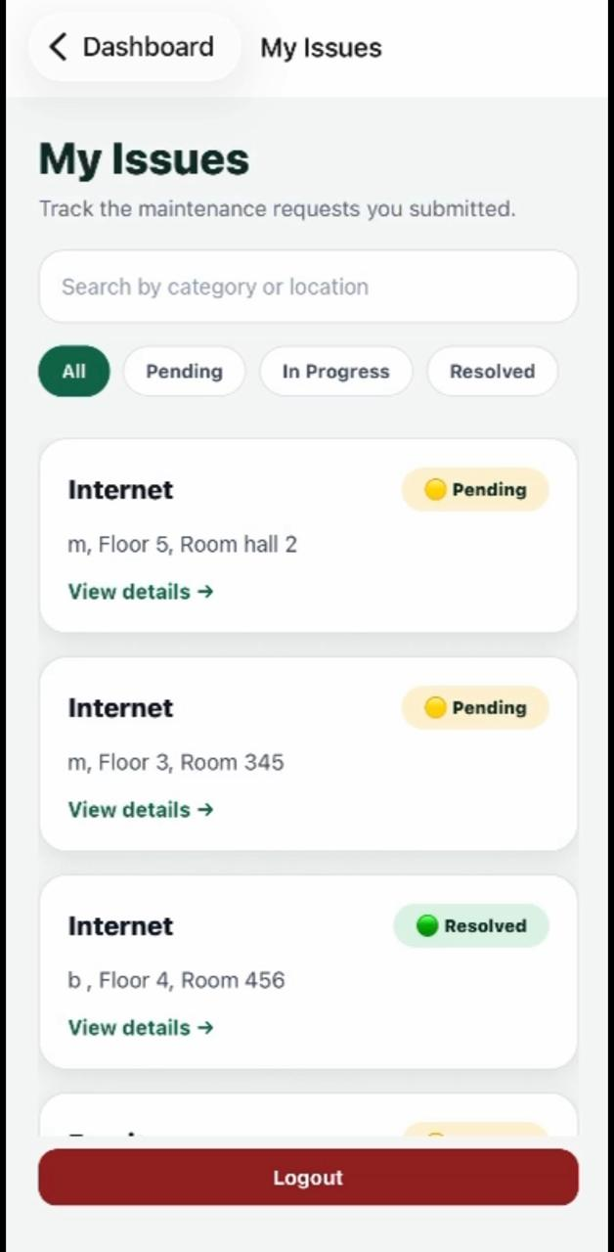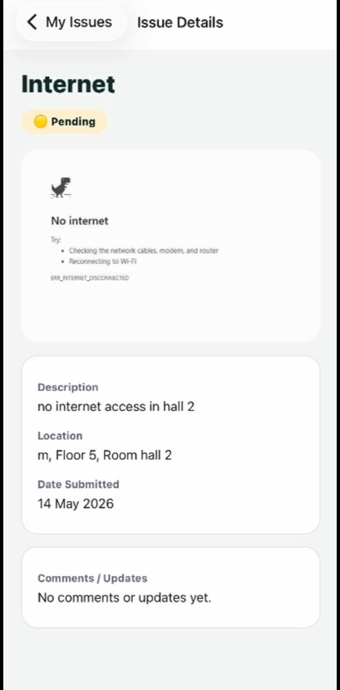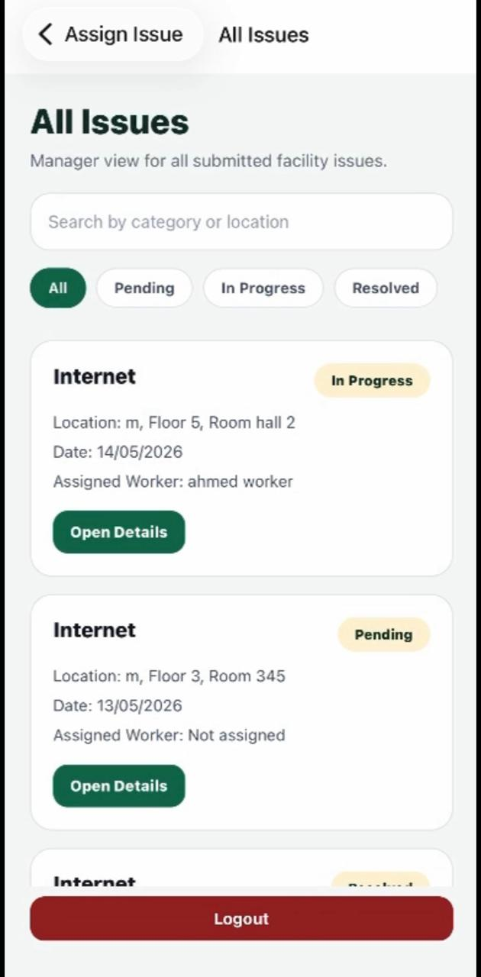
9.Project Structure Overview:
Backend
backend/
├── controllers/
├── middleware/
├── routes/
├── models/
├── config/
├── server.js
Description:
• controllers/: business logic
• routes/: API routes
• middleware/: authentication and authorization
• models/: database queries
• config/: database configuration

Frontend
frontend/
├── screens/
├── components/
├── navigation/
├── services/
├── App.js

Description:
• screens/: application screens
• navigation/: React Navigation setup
• services/: API requests
• components/: reusable UI components

